**ROBOTICS ASSIGNMENTS**

|  |  |  |  |  |
| --- | --- | --- | --- | --- |
|  |  | INDEX |  |  |
| NO | DATE | TITLE | PAGE NO | SIGN |
|  |  |  |  |  |
| 1. |  | Write a program to make use of track image and move in white area. |  |  |
| 2. |  | Write a program to create a robot with gear that does a circle. |  |  |
| 3. |  | Write a program to create a robot that does a rectangle. |  |  |

**Assignment 1**

**AIM:** Write a program to make use of track image and move in white area.

**CODE:**

package robotics;

import ch.aplu.robotsim.*;

public class RobotSensorTrackFollower {

static {

RobotContext.setStartPosition(80, 438);

RobotContext.useBackground("sprites/track.png");

}

public RobotSensorTrackFollower() {

LegoRobot legoRobot = new LegoRobot();

Gear gearBox = new Gear();

LightSensor lightSensor = new LightSensor(SensorPort.S3);

legoRobot.addPart(gearBox);

legoRobot.addPart(lightSensor);

gearBox.forward();

gearBox.setSpeed(100);

while (true) {

if(lightSensor.getValue() > 10){

gearBox.forward();

}

else{

gearBox.rightArc(0.03);

}

}

}

public static void main(String[] args) {

new RobotSensorTrackFollower();

}

}

**OUTPUT:**

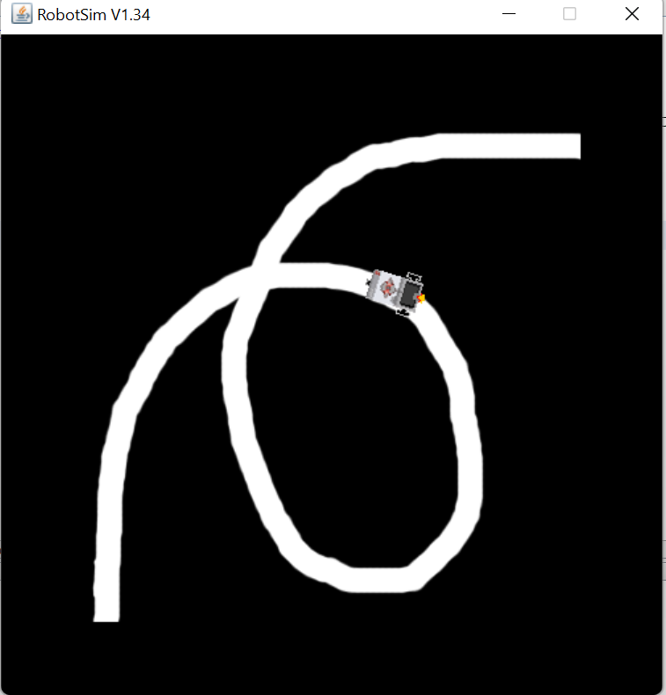

**Assignment 2**

**AIM:** Write a program to create a robot with gear that does a circle.

**CODE:**

package robotics;

import ch.aplu.robotsim.*;

public class MoveWithGearCircle {

public MoveWithGearCircle(){

NxtRobot robot = new NxtRobot();

Gear g = new Gear();

robot.addPart(g);

for(int i =1;i!=0;i++){

g.forward(200);

g.right(200);

}

}

public static void main(String []args){

new MoveWithGearCircle();

}

}

**OUTPUT:**

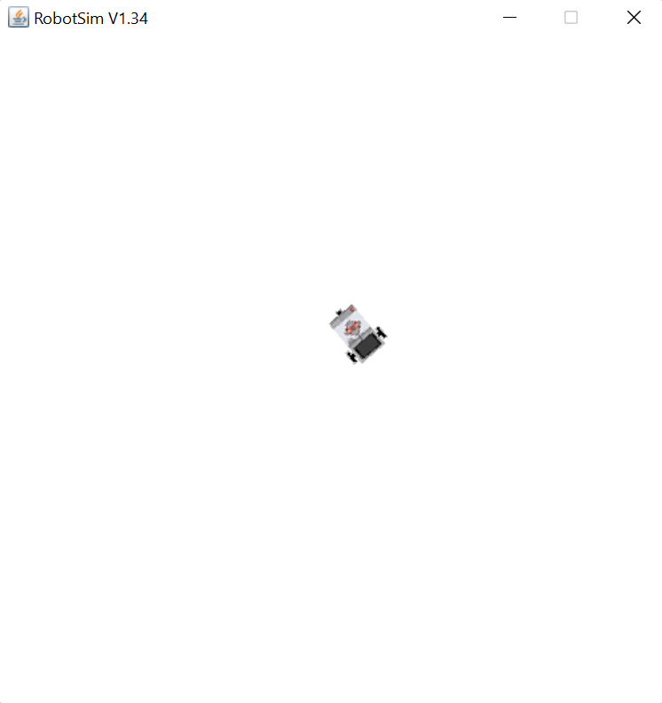

**Assignment 3**

**AIM:** Write a program to create a robot that does a rectangle.

**CODE:**

package robotics;

import ch.aplu.robotsim.*;

public class MoveWithGearRect {

public MoveWithGearRect(){

NxtRobot robot = new NxtRobot();

Gear g = new Gear();

robot.addPart(g);

g.right(550);

g.forward(2500);

g.left(550);

g.forward(1000);

g.left(550);

g.forward(2500);

g.left(550);

g.forward(1000);

robot.exit();

}

public static void main (String [] args){

new MoveWithGearRect();

}

}

**OUTPUT:**

